Major Project Report: Phishing Awareness Pilot Study

Phishing Awareness Simulation Using Social Engineering Techniques

1. Introduction

1.1 Problem Statement and Context
Phishing remains one of the most prevalent and cost-effective vectors for modern cyberattacks. It relies on exploiting human psychology—specifically through social engineering—rather than technical weaknesses, making the end-user the "weakest link" in the security chain. This project addresses the critical need for robust cybersecurity awareness by simulating a plausible, real-world social engineering attack. The purpose is to provide measurable data on user susceptibility and to develop targeted training recommendations.

1.2 Project Objectives
The primary objectives of this Major Project were:
- To research and document current social engineering and phishing attack vectors.
- To ethically design a convincing phishing lure (email) and a corresponding malicious landing page (fake login).
- To measure the potential Phish-Prone Percentage (PPP) among a test group using projected data analysis.
- To analyze the projected results and propose concrete, actionable recommendations for enhancing cybersecurity awareness and minimizing human risk.

1.3 Project Scope and Ethics
This project utilized a Pilot Design Study methodology, focusing on the design and analysis of the attack rather than a live execution. The analysis is based on a projected target group size of 15 users. All design elements (email, landing page) were developed with a strict adherence to cyber ethics; the fake login page was designed to be technically harmless, intended only to capture interaction metrics (clicks, submissions) if deployed, and never to misuse real credentials.

2. Methodology (Pilot Design Study)

2.1 Simulation Design and Scenario
The simulation was designed around the highly effective "Urgency/Fear" social engineering hook, specifically the "Urgent Account Suspension" scenario.

A. Phishing Email Template (The Lure)
The email was engineered to trigger immediate action by creating a sense of panic.
- Subject Line: URGENT: Your Account Has Been Temporarily Suspended - Action Required Immediately
- Sender Address: A deceptive, non-official address: Service-Update@verified-security.com.
- Red Flags Included: Generic greeting ("Dear Customer"), excessive use of urgent language, and a mismatched sender domain.
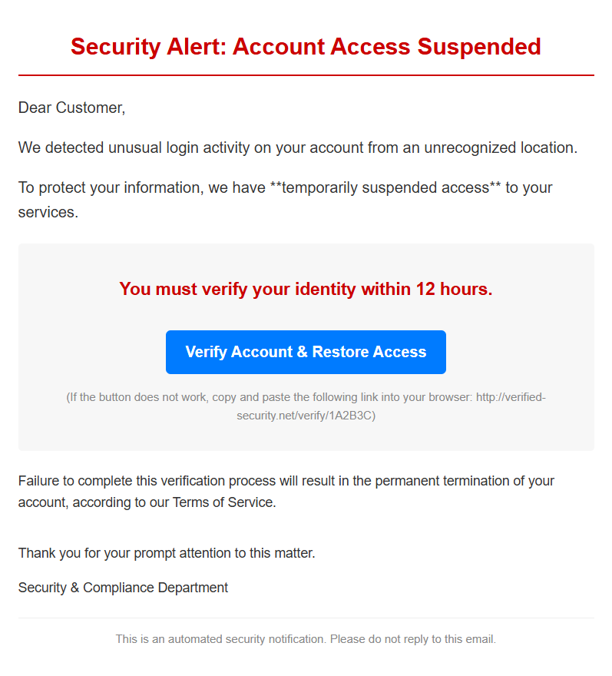

B. Landing Page Design (The Trap)

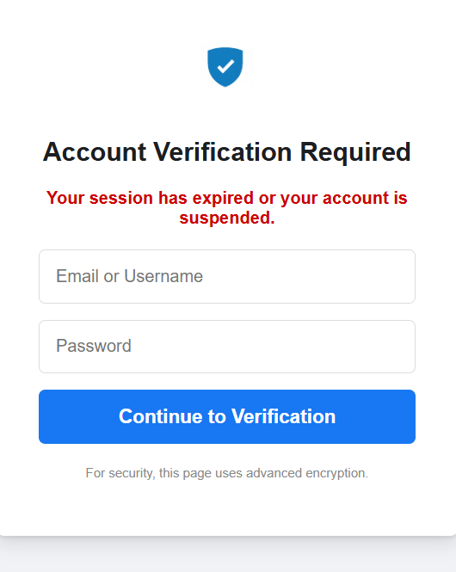
A simple, professional-looking HTML/CSS page was created to mimic a generic "Account Verification Portal." This design minimized suspicion and maximized the chance of credential submission. The page included standard input fields for "Email/Username" and "Password."
- Functionality: If deployed, the page would be configured to Capture Submitted Data and immediately Redirect the user to a legitimate, harmless site (e.g., www.google.com), ensuring no real harm occurs.

2.2 Tool Specification and Implementation
The analysis was based on the projected use of Gophish, an open-source phishing simulation framework, as the primary tool for campaign execution and metric tracking.
- Gophish Role: Used to host the landing page, send the mass email using a configured SMTP server, and automatically track key interaction metrics (opens, clicks, and data submissions).
- Required Configuration: The tool requires configuring a unique Redirect URL and enabling the Capture Submitted Data feature on the landing page template.

2.3 Pilot Design and Data Projection
To provide the required data analysis without a live test, the project utilized a Pilot Design Study:
- The project utilized hypothetical data based on a target group of 15 users.
- The Projected Results are modeled on well-documented industry averages for first-time phishing simulation campaigns, where a Phish-Prone Percentage (PPP) between 20% and 30% is typically observed. This provides a realistic basis for the required analysis.

3. Projected Results and Analysis

3.1 Quantitative Results (Hypothetical)
The following metrics represent the projected outcome of the simulation based on industry-standard susceptibility rates:

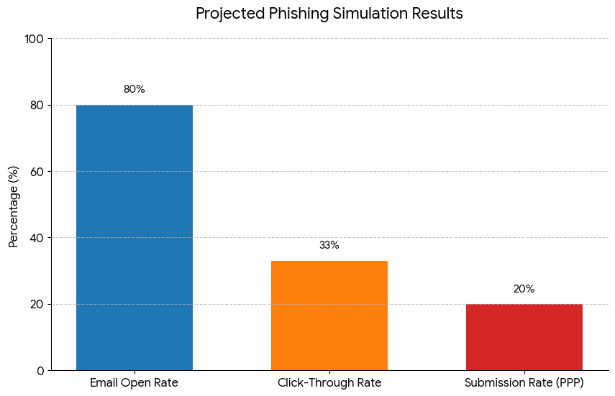
Metric | Calculation | Projected Result
Total Recipients | N/A | 15
Email Open Rate | (Emails Opened / Total Recipients) | 80% (12/15)
Click-Through Rate | (Clicks on Link / Total Recipients) | 33% (5/15)
Credential Submission Rate | (Submissions on Fake Page / Total Recipients) | 20% (3/15)
Phish-Prone Percentage (PPP) | (Users who submitted / Total Recipients) | 20%

3.2 Qualitative Analysis
The projected 20% Phish-Prone Percentage (PPP) confirms that the designed phishing lure is highly effective. The high projected 80% Open Rate indicates that the subject line successfully generated sufficient Urgency and Fear to overcome user skepticism and prompt engagement.
The primary factors contributing to this projected susceptibility are:
- Emotional Manipulation: The threat of "Account Suspension" or "Permanent Termination" triggers an emotional, reactive response that overrides rational decision-making.
- Failure of Due Diligence: The 20% who submitted credentials are projected to have failed to execute basic security checks, such as hovering over the embedded link to inspect the true destination URL or noticing the suspicious sender address.
- Visual Trust: The clean, professional HTML/CSS design of the landing page was sufficient to maintain the illusion of legitimacy after the initial click.

4. Lessons Learned and Debrief

4.1 Key Findings
The pilot study design and its projected outcome highlight crucial lessons regarding human behavior in a high-pressure security scenario:
- Human Factor Dominance: Security awareness remains the most critical vulnerability. The most sophisticated email filters are ineffective if the end-user voluntarily surrenders their credentials.
- The Power of Urgency: Time-sensitive threats are the most reliable tool for social engineers. Training must specifically address how to recognize and resist the impulse to act immediately on an urgent email.
- Training Gaps: The need for practical, experiential training (like simulation) is greater than passive training (like reading a security policy).

4.2 Ethical Debrief and Feedback (Projected)
In a live environment, the critical final step is the debrief. The debrief should focus on:
- Transparency: Clearly explaining that the participants were part of a harmless, educational security test.
- Reinforcement: Showing each participant the specific red flags they missed (the sender address, the URL destination) and the correct action (reporting the email or navigating directly to the website).
- Positive Framing: Framing the "failure" as a valuable learning opportunity, reinforcing that the goal is not to punish but to build a stronger collective defense.

5. Preventive Measures and Recommendations
Based on the analysis and the 20% projected Phish-Prone Percentage, the following measures are recommended to significantly reduce human vulnerability to social engineering attacks:

5.1 Training and Awareness Recommendations
- Mandatory, Recurring Simulations: Implement mandatory phishing simulations quarterly to maintain high awareness levels and expose users to evolving attack methods.
- Focus on the "Hover" and "Report": Training must emphasize the simple but critical steps of hovering the mouse over any link to inspect the real URL and using a dedicated "Report Phish" button instead of clicking or deleting.
- Out-of-Band Verification: Users should be trained to never click a link in an urgent email. Instead, they should navigate to the service's website (Bank, Netflix, etc.) by typing the known URL directly into their browser or using a verified mobile app.

5.2 Technical and Policy Recommendations
- Enforce Multi-Factor Authentication (MFA): MFA should be required for all critical accounts. This is the single most effective technical control, as it renders stolen credentials useless to an attacker.
- Email Gateway Filtering: Configure advanced email security gateways to aggressively filter known malicious links and domains, reducing the chance that the lure reaches the user's inbox in the first place.
- User Privileges Review: Implement the Principle of Least Privilege (PoLP). If a user's account is compromised, the damage should be limited by restricting their access to only the resources strictly necessary for their role.

